Debug SDRAM bank1 screen shot record:
- Use sdram bank 0 -- working (buffer1 is able to write into it.)
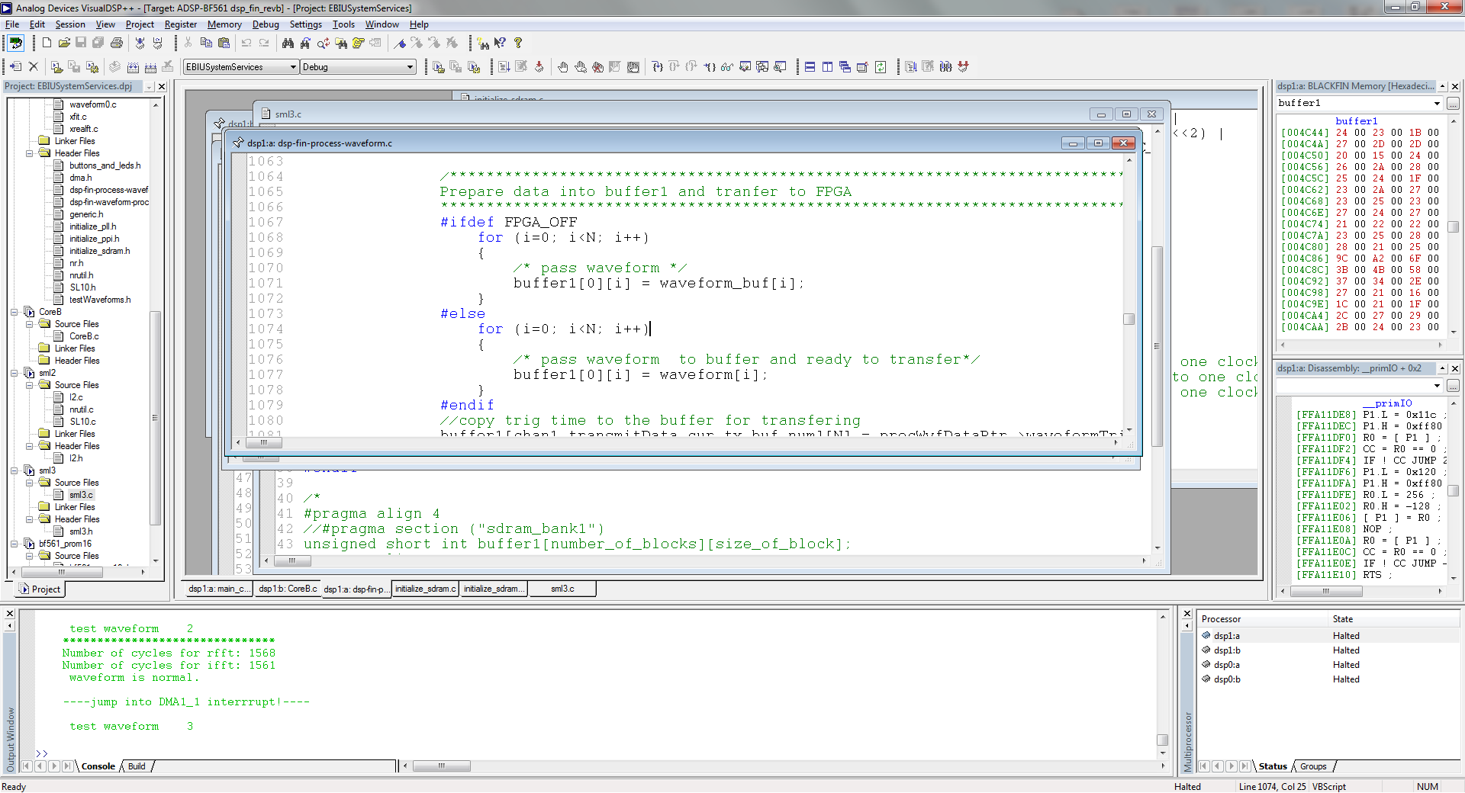

- Use sdram bank1 --- not work (buffer 1 can’t be write into it.)
After load, got a warning:
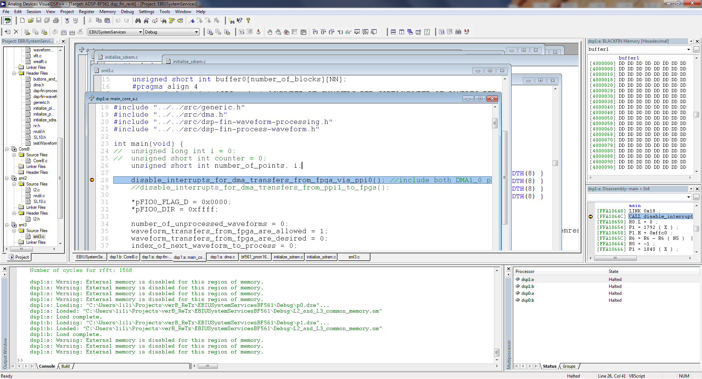

During program run: - buffer1 can’t write into it
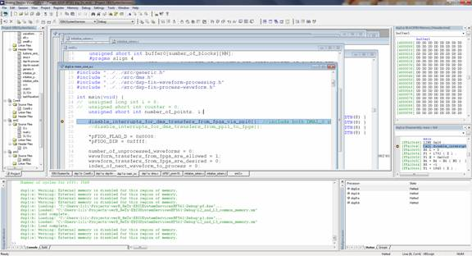

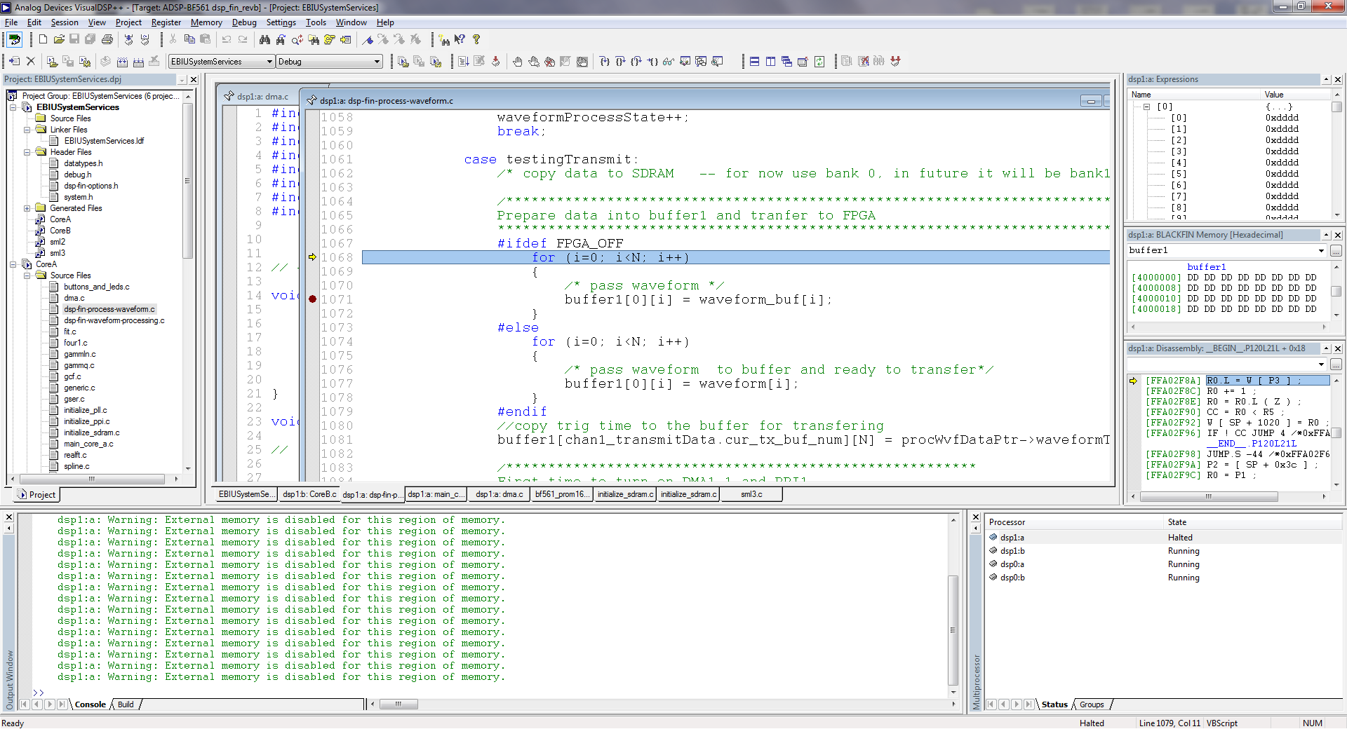
Note: dsp1:a Warning: External memory is disabled for this region of memory.

- Use sdram bank2 and bank 3 all failed like bank1.
- 